# Mainframe VSAM Employee Data Query Tool

## The Purpose

An organization has all of its employee data in VSAM Datasets on their IBM z Series mainframe. They want to make this data available to authorized employees to use AI to allow Natural Language queries to be made against the data.

## The Challenge

There are significant challenges to using data from Mainframe VSAM files:

1. Access to any mainframe resources are strictly secured and controlled.
2. VSAM cannot easily be integrated into an AI Process as the data is in a different code page and the technology is not directly accessible.
3. VSAM datasets do not have any meta data about the data included so this must be provided in the form of a COBOL Copybook or similar to correctly interpret the data.
4. The additional load from AI directly on these mainframe resources would not be acceptable from both a cost and performance perspective.

## The Configuration

Ostia and SnapLogic have developed the tools to automatically make this data available to be accessed from an AI Agent as follows:

1. Install Ostia’s Portus Integrate tool on the mainframe system.
2. Create Portus services for each of the VSAM files using the relevant COBOL Copybook.
3. Create a Snap Logic pipeline….
   1. Use the Soap Execute Snap to extract the data directly from each VSAM file and format using the COBOL Copybook data.
   2. Process the data through an Embedder and upsert into a Pinecone database. 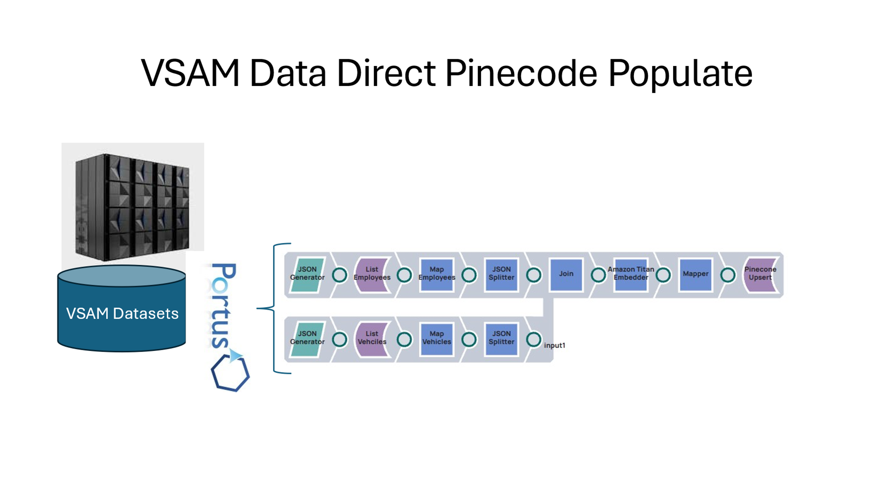
4. Once the data is into the Pinecode database, it can be access using the AI Agent:

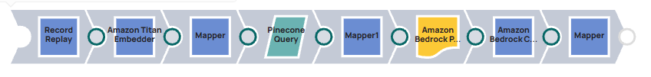

## Sample Queries

1. Which employees own a vehicle ?
2. How many makes of vehicles are owned by employees ?
3. What is the total amount of vacation days remaining for all employees ?